Prayer - House of Hope

Please commit to pray each day in your communities and families.
Before or after your family meal.

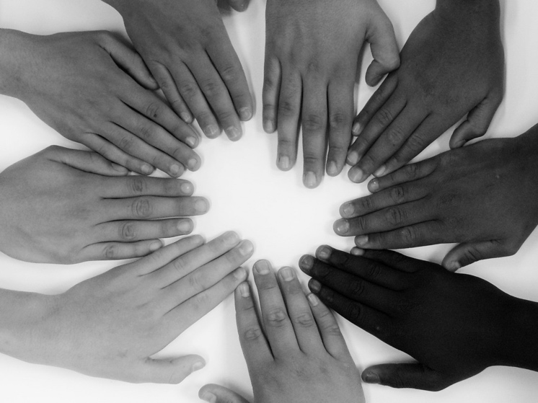

Opening Prayer – Blessed be the longing

Blessed be the longing that
brought you here and that
quickens your soul with wonder.
May you have the courage to befriend your
eternal longing.
May you enjoy the critical and creative
companionship of the question:
'Who am I?' and may it brighten your longing.
May a secret providence guide your thought
and shelter your feelings.
May your mind inhabit your life with the
same sureness with which your body
belongs in the world.
May the sense of something absent enlarge
your life.
May your soul be as free as the ever-new
waves of the sea.
May you succumb to the danger of growth. May you live in the neighbourhood of
wonder.
May you belong to love with the wildness of
dance.
May you know that you are ever-embraced in
the kind circle of God.

Gospel – Search
Matthew 7:7-11
‘Ask, and it will be given to you; search, and you will find; knock, and the door will be opened for you. For everyone who asks receives, and everyone who searches finds, and for everyone who knocks, the door will be opened. Is there anyone among you who, if your child asks for bread, will give a stone? Or if the child asks for a fish, will give a snake? If you then, who are evil, know how to give good gifts to your children, how much more will your Father in heaven give good things to those who ask him!
The Gospel of the Lord.
ALL – Praise to you Lord Jesus Christ.

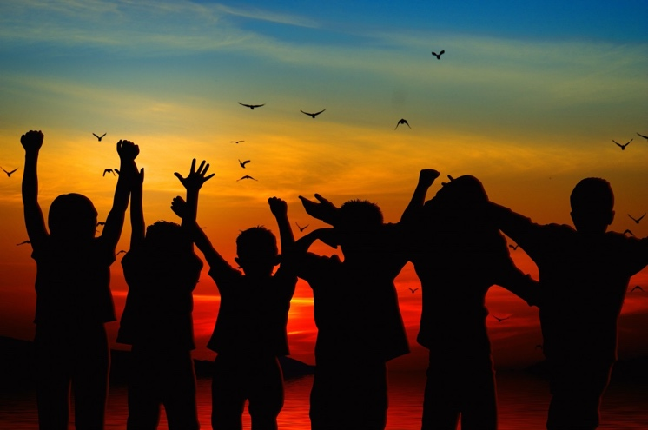

Story - House of Hope
In the Philippines the Marist Sisters run a “House of Hope” and ‘safe place’ for girls at risk of abuse. The Centre provides shelter, called Balay Banaag, supports, educates and provides an opportunity to break the cycle of poverty for ‘at risk behaviours and abuse of girls’. These young girls come from families at risk and are very vulnerable to exploitation and abuse. Balay Banaag offers these girls a future with dignity, hope and independence.

There are currently ten girls in the care of Balay Banaag aged between 6 and 18 years old. Most of the children do not know who their father is and many have suffered physical and emotional abuse because of their upbringing.

Reflection
Pause and take 1 minute to reflect silently on the Gospel and the story of Balay Banaag.

Discuss
Discuss the following questions with those gathered:
1. Why is hope important for the girls at Balay Banag?
2. What did Jesus teach about searching?
3. When have you searched?

Prayers of intercession
1. We pray for the girls at Balay Banaag and the Marist Sisters, such as sister Lilibeth, sister April and sister Sheila and others, who care for them. Give them a future filled with hope. Encourage them, heal them, and inspire them to make a difference in the lives of women in need.
Lord hear us.
All – Lord here our prayer.

2. We pray for those searching and those who are lost especially the young. God give them the courage to search for the light even though sometimes things may seem dark.
Lord hear us. Lord hear us.
All – Lord here our prayer.

3. We pray for women facing domestic violence in our own country and in our world. Gives these women the courage to stand up for human dignity and may men advocate and become beacons and models who care for women with a deeper love, respect and compassion.
Lord hear us.
All – Lord here our prayer.

Are there any other prayers?

Final prayer – Family Millennium pledge
Dear Lord,
We wish to follow Your mother Mary.
Inspire us to find the things in our lives
that will bring us closer
to being Mary’s hands, mind, and heart.
May we bring the love of God living in us
to care for the poor, the needy, and the forgotten.
Call us to go beyond our comfort zone
to bring hope to the world and a future
not our own.
Teach us to be open to Your way.
To listen.
To ponder.
To feel joy. To be brother or sister to others.
Especially in times of struggle.
Enable us to be committed,
to Mary’s way in our life,
to follow your Son Jesus.
Amen.

Closing Song
When we believe
https://www.youtube.com/watch?v=sXH7HXlj5Lo

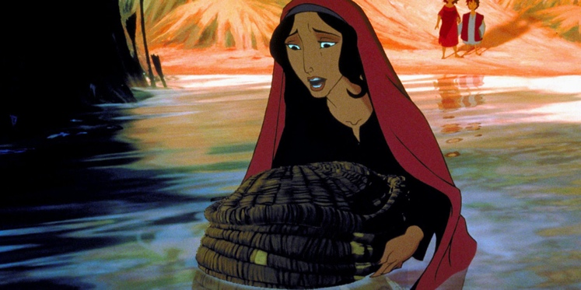

Mary mother of Mercy Pray for us.
Joseph her loving husband Pray for us.
All our Saints Pray for us.

Sign of the Cross
In name of the Father, and of the Son and of the Holy Spirit. Amen

